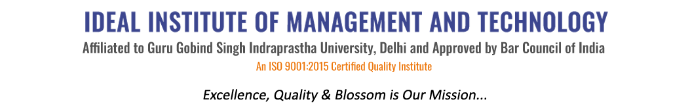
16 X, Karkardooma Institutional Area, (Near Telephone Exchange)
Delhi-110092
+91 (11) 22372639, 22375961,
http://idealinstitute.edu.in
RELAXO on 27th February,2017
S.NO | NAME OF THE STUDENT
 | Prashant
 | Harkaran
 | Sahil
 | Anurag
 | Ashish
 | Jeffin
 | Jaivardan
 | Rachit
 | Naveen
 | Vikas
 | Abhinav
 | Kunal
 | Sidharth
 | Shaurya
 | Vicky
 | Komaljeet
 | Simran
 | Arunav
 | Naina
 | Tanu
 | Sheetal
 | Surbhi
 | Ritika
 | Shivani
 | Sushma
 | Girish
 | Preeti
 | Mohit Madan
 | Abhishek Mohan
 | Lalit Sharma
 | Divya Batra
 | Piyush
 | Pranshu Rastogi
 | Naman Jain
 | Megha Gola

