DOCUMENTS TO BE UPLOADED
6.2.1
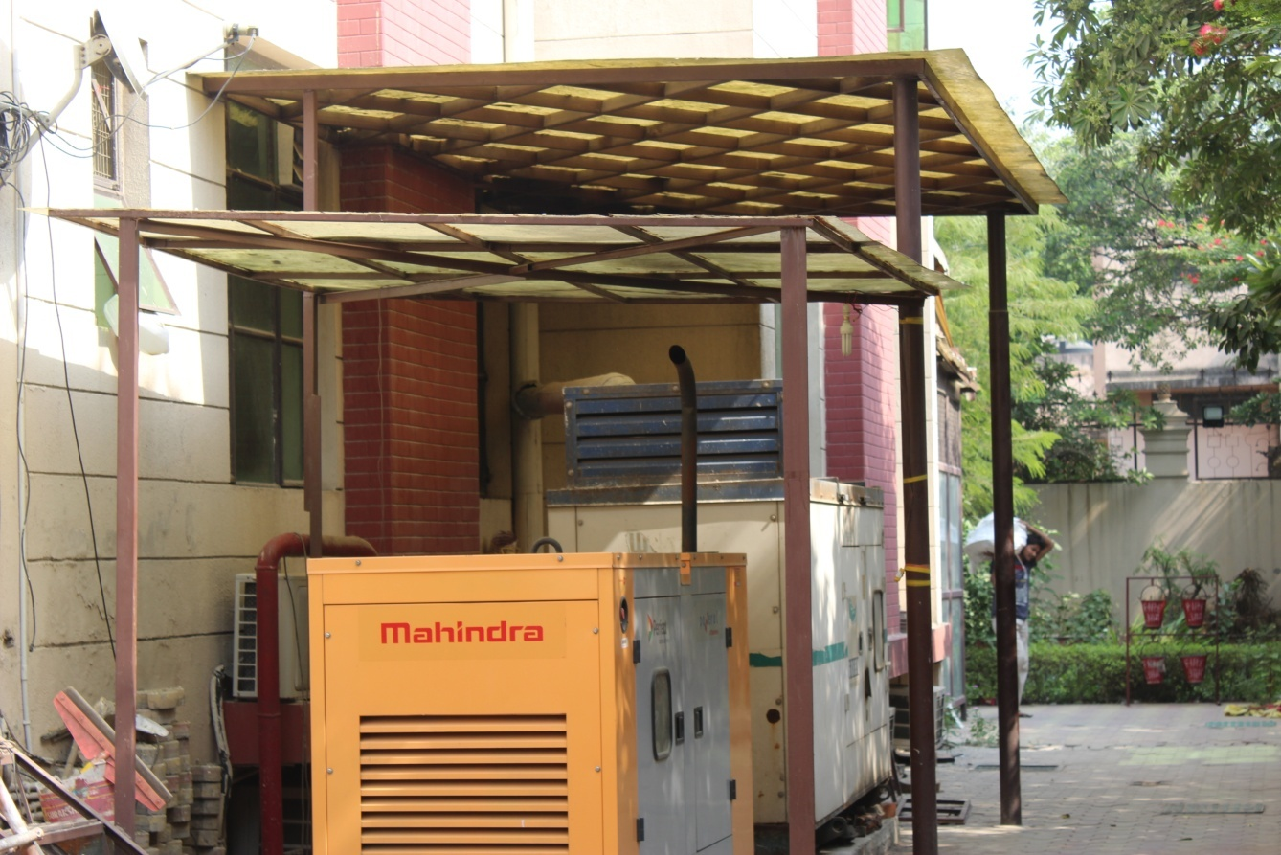

BACK-UP FACILITIES WITH GENERATORS
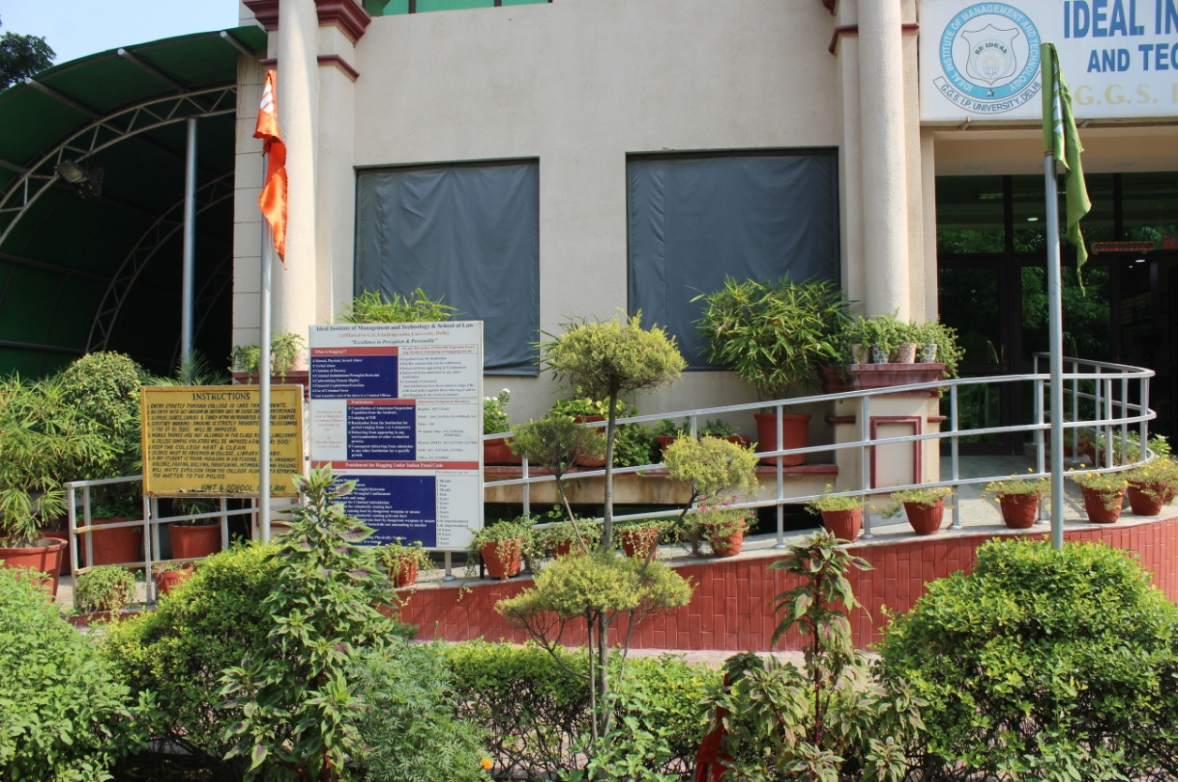
RAMP FACILITY
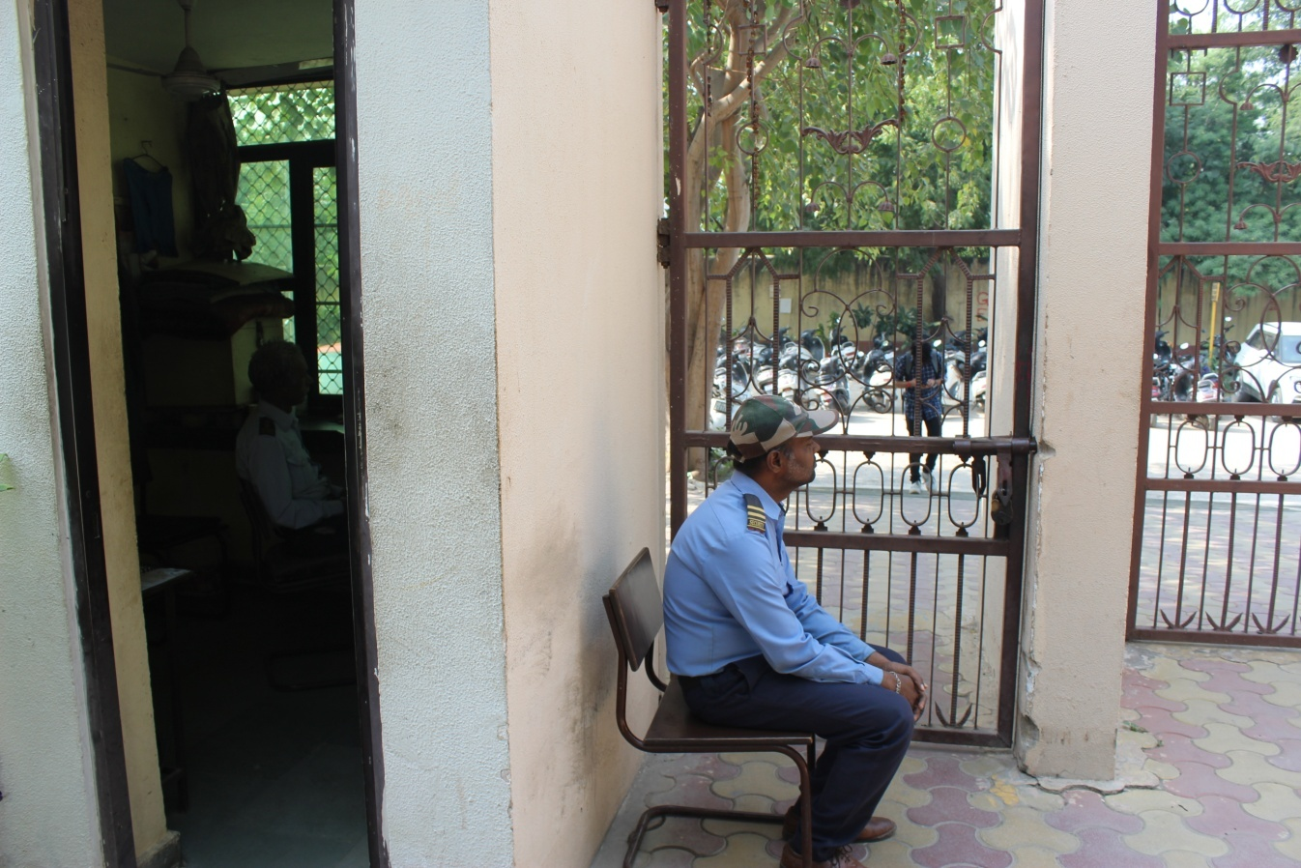
GUARD ROOM
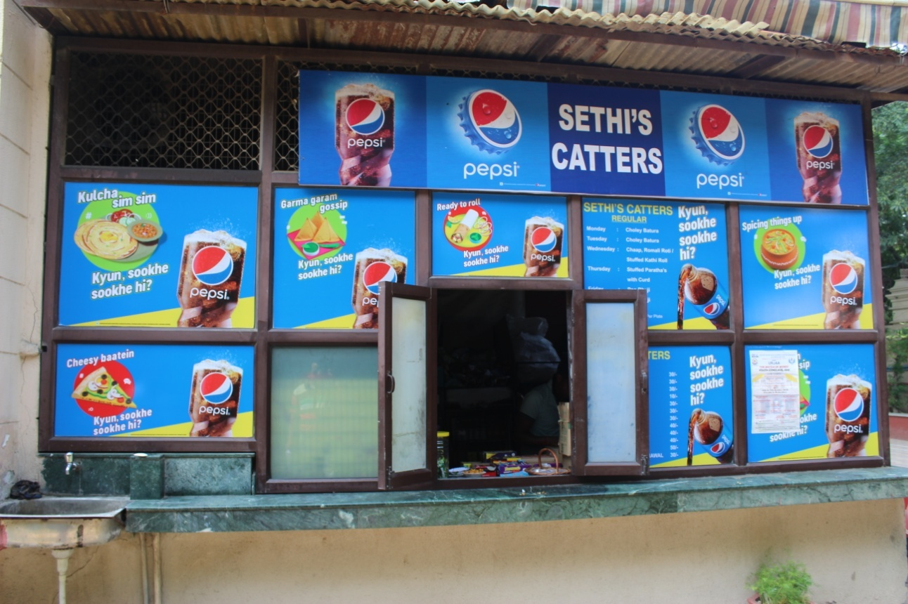
CANTEEN

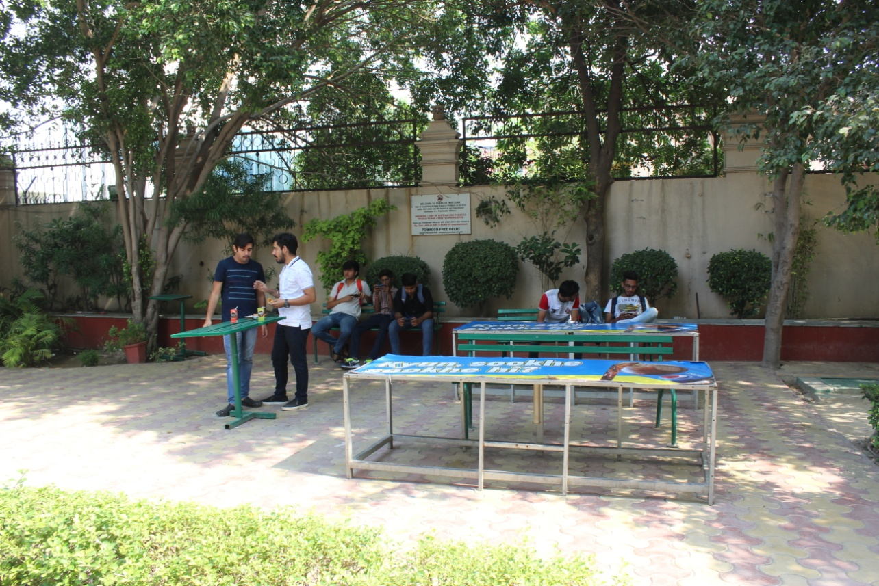

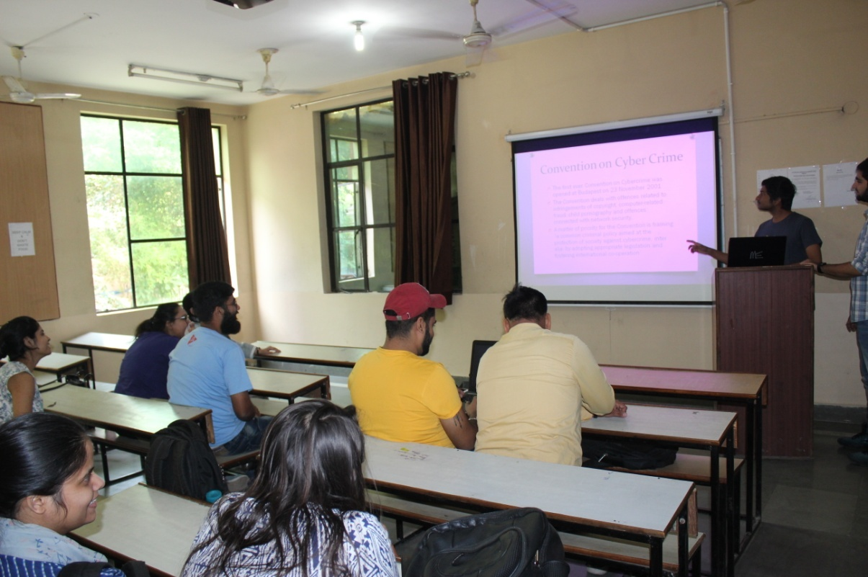
PROJECTOR ROOM
REST ROOM
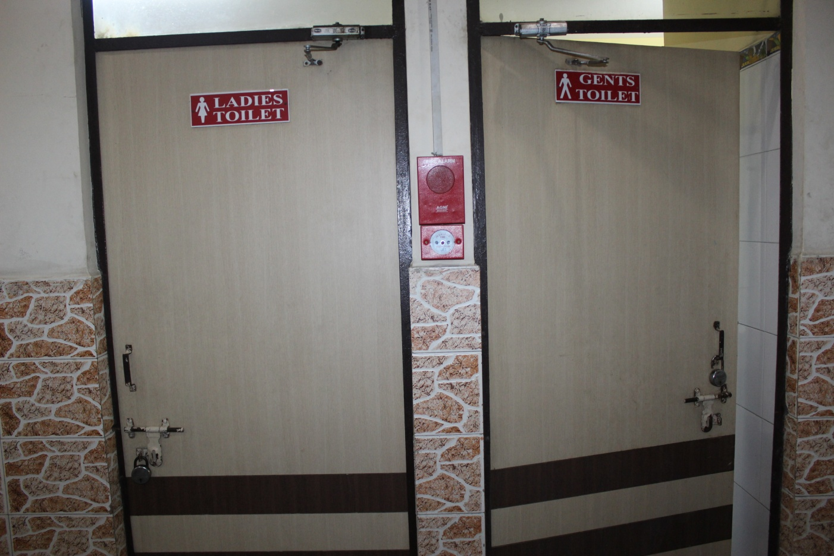

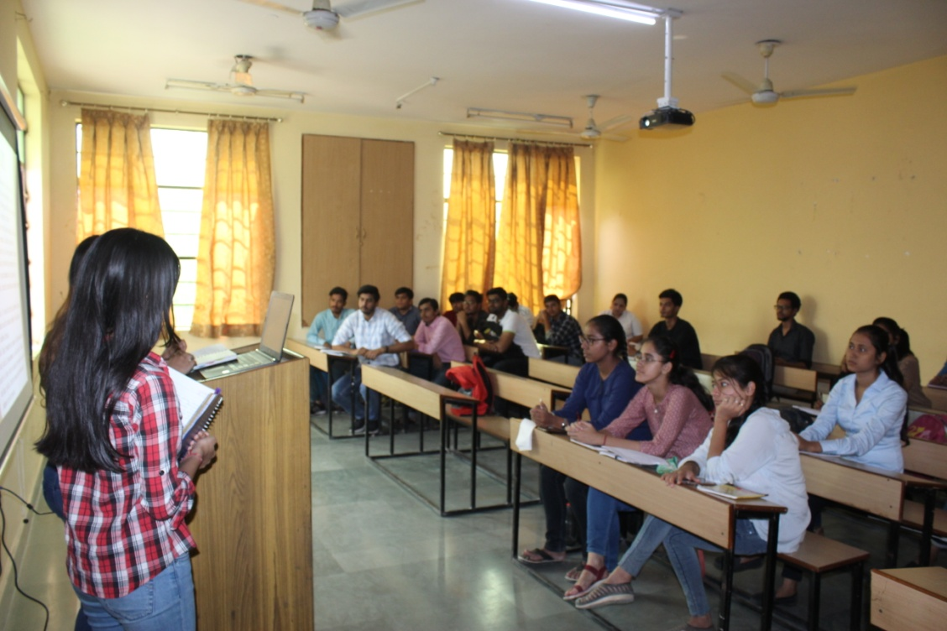
CLASS ROOM

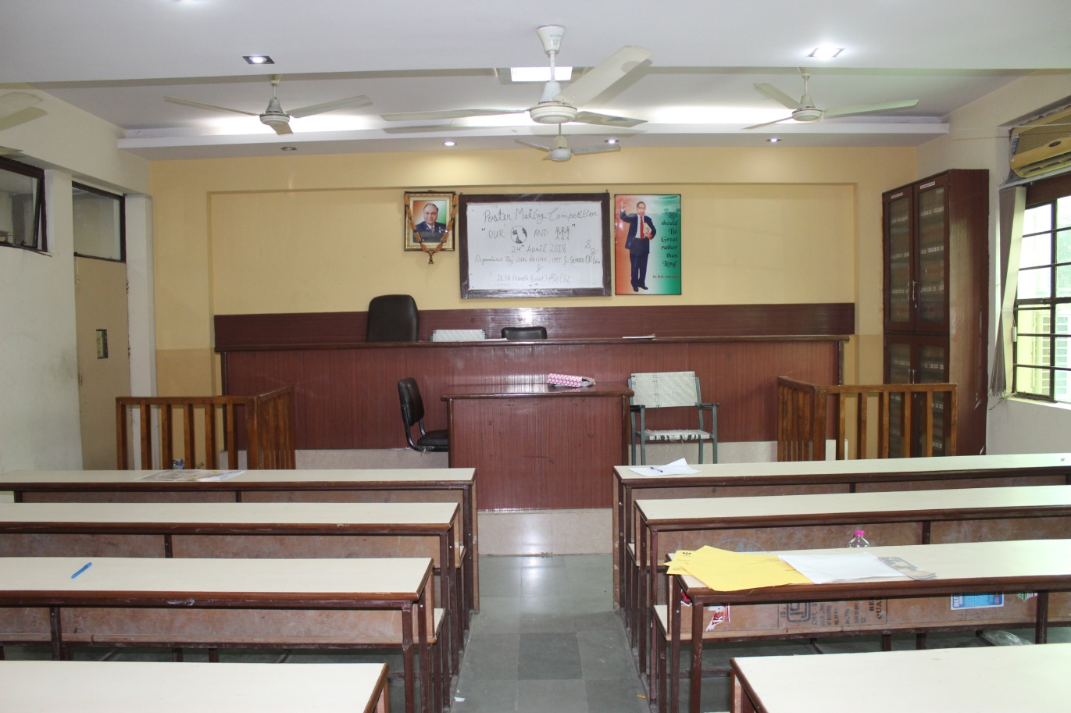
MOOT COURT

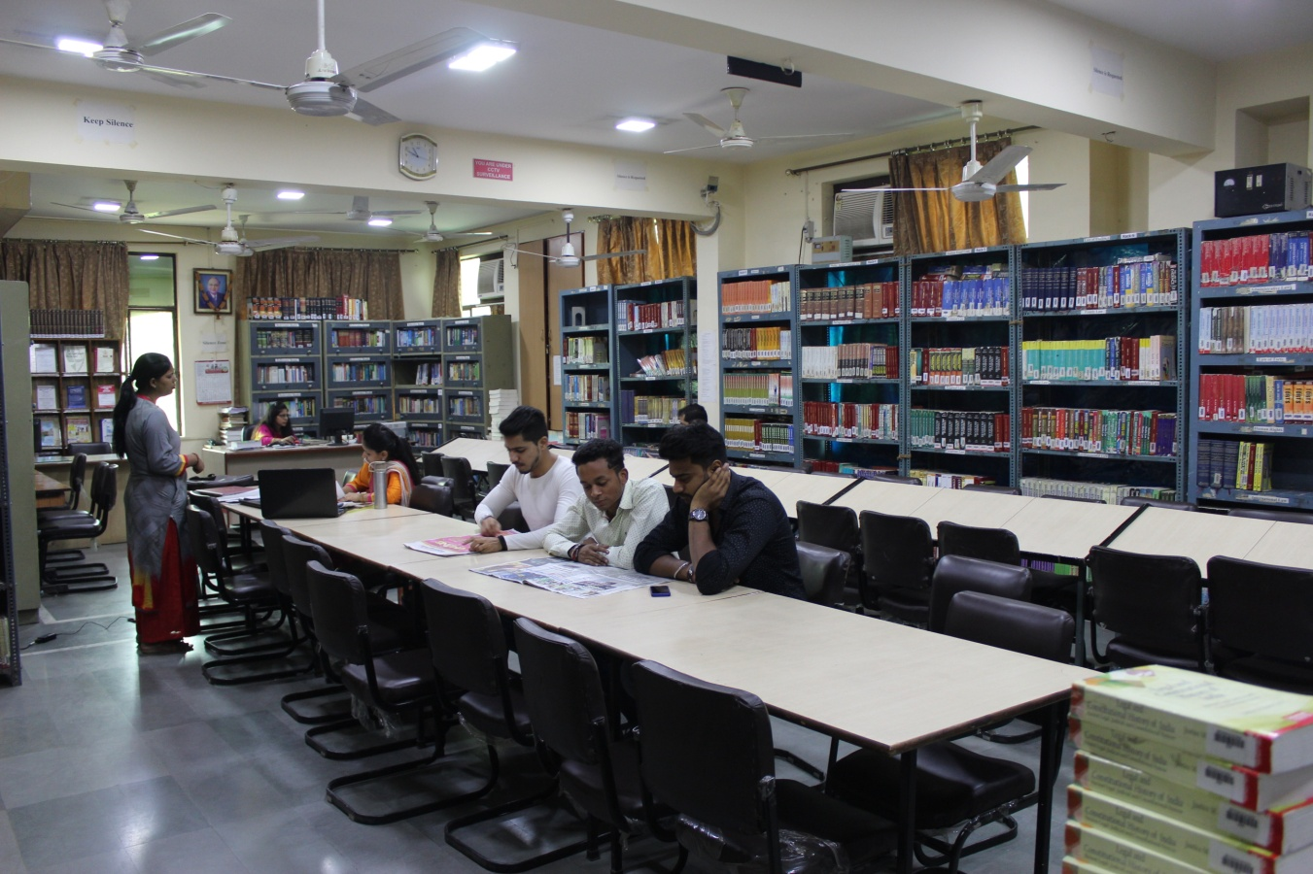
LIBRARY LAW DEPARTMENT
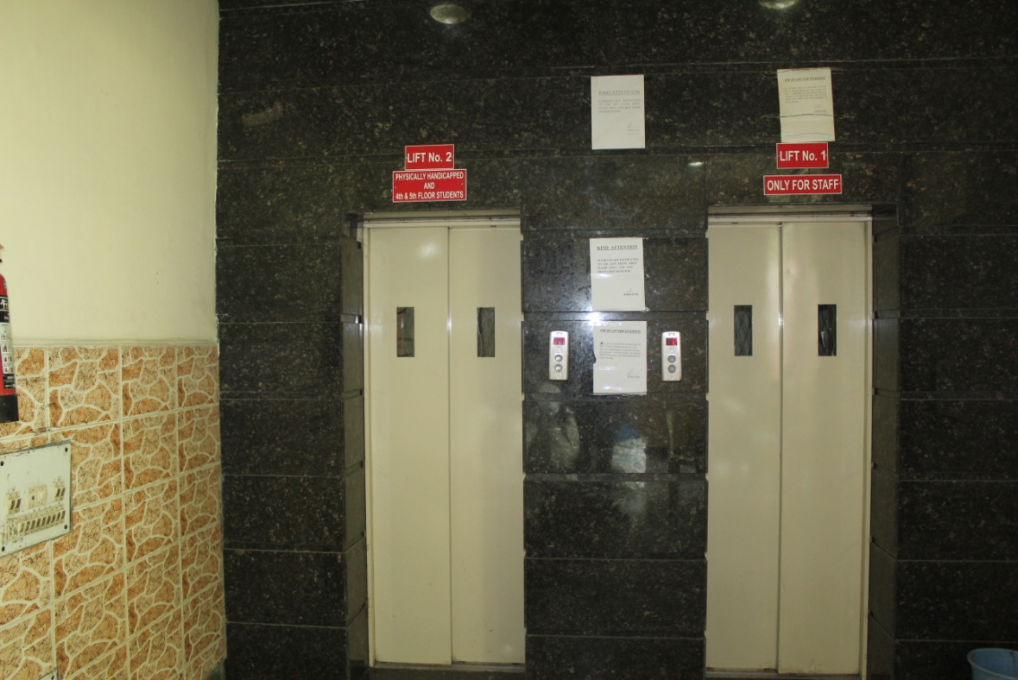
LIFT FACILITY
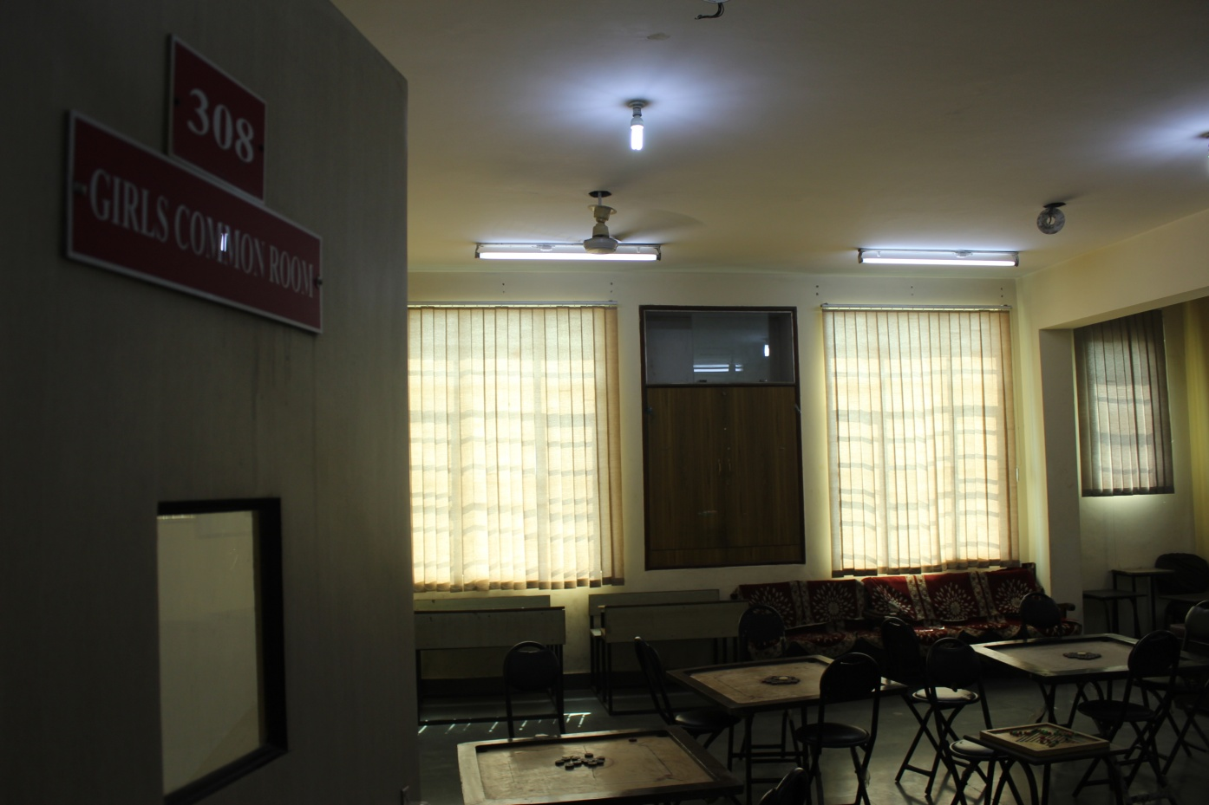
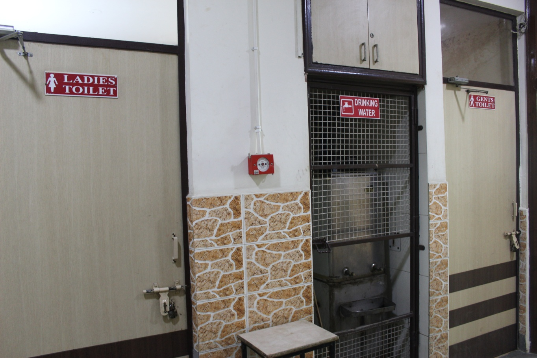

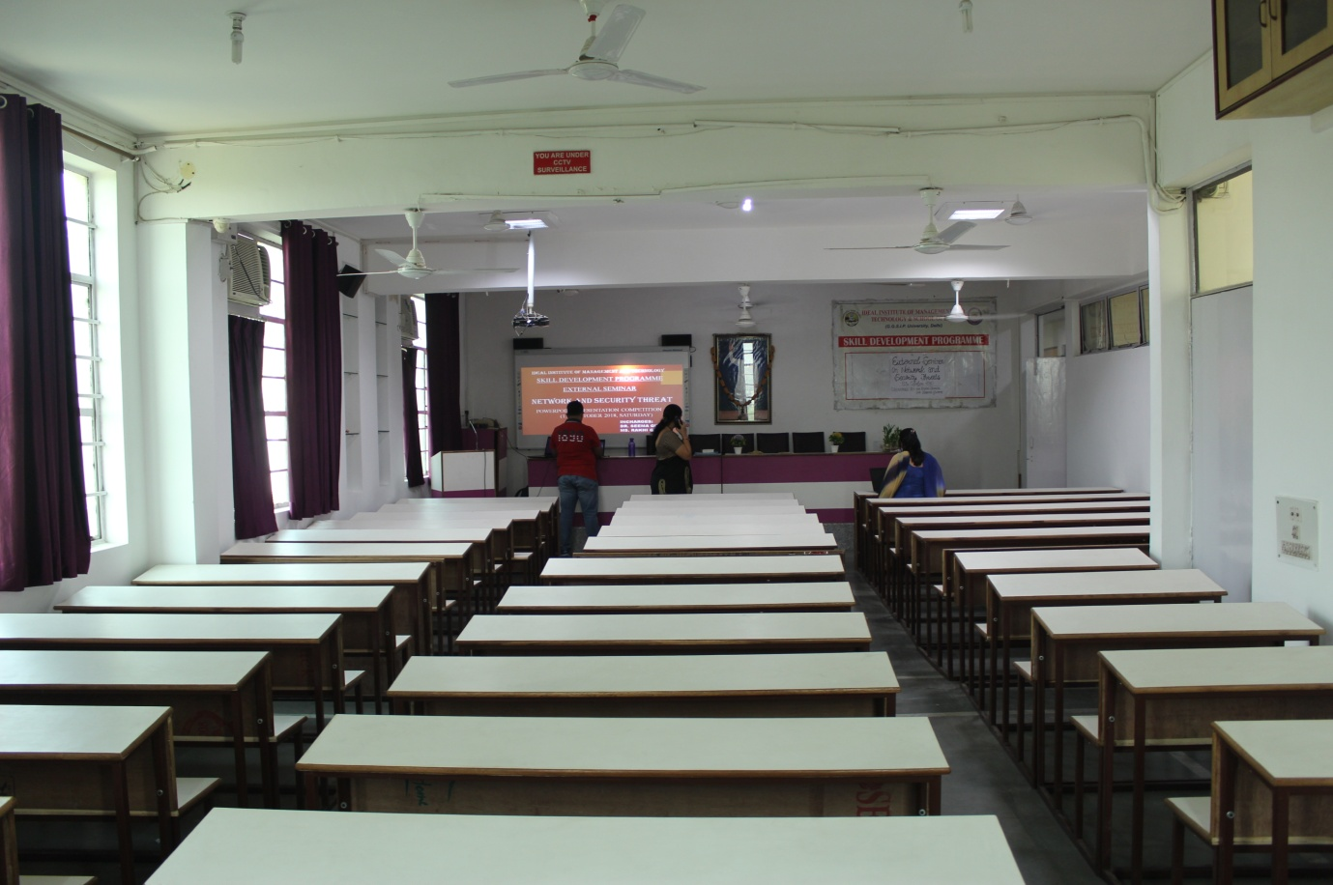
MINI AUDITORIUM
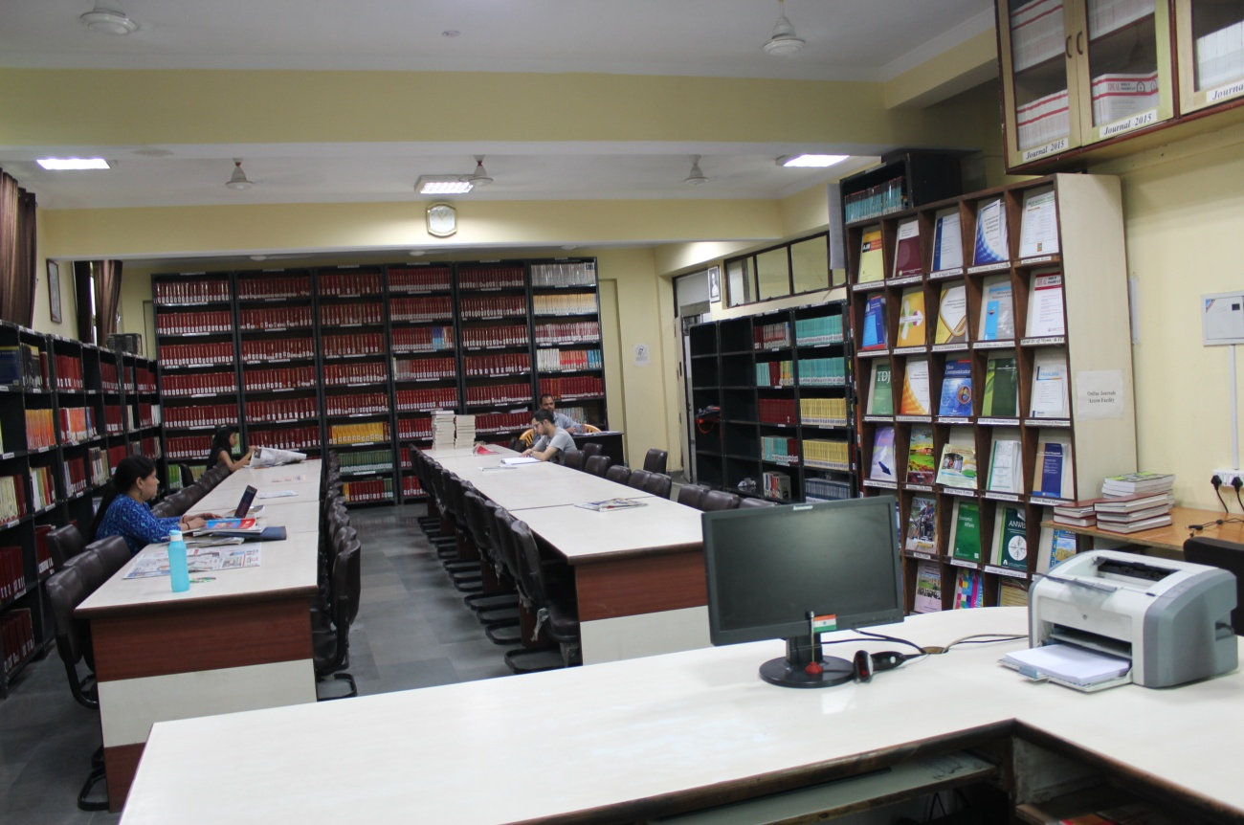
LIBRARY MANAGEMENT DEPARTMENT
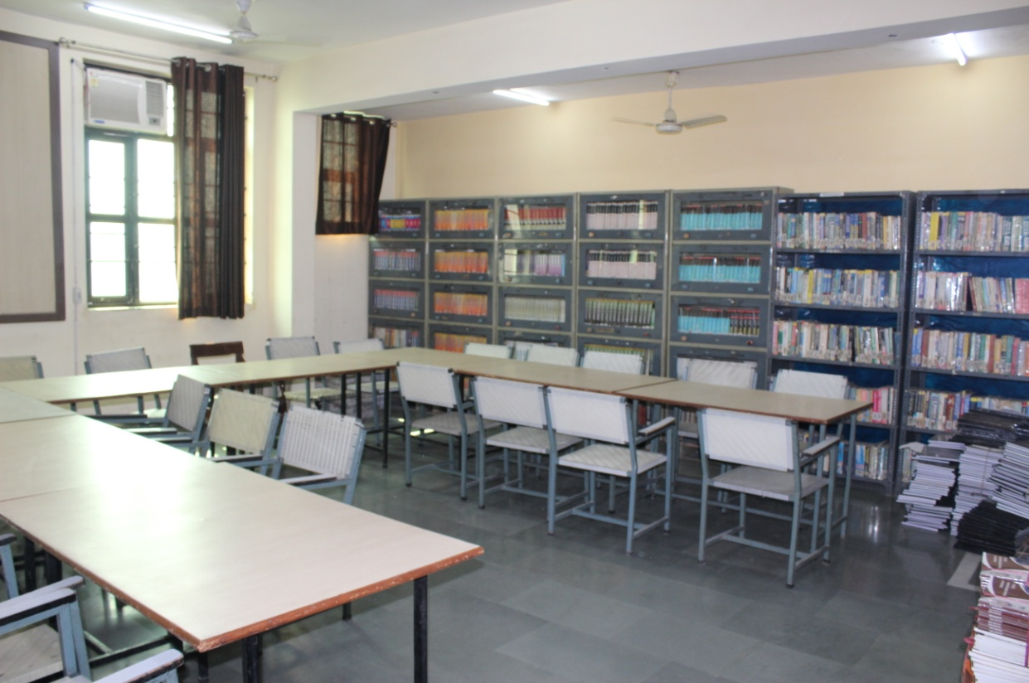
READING ROOM
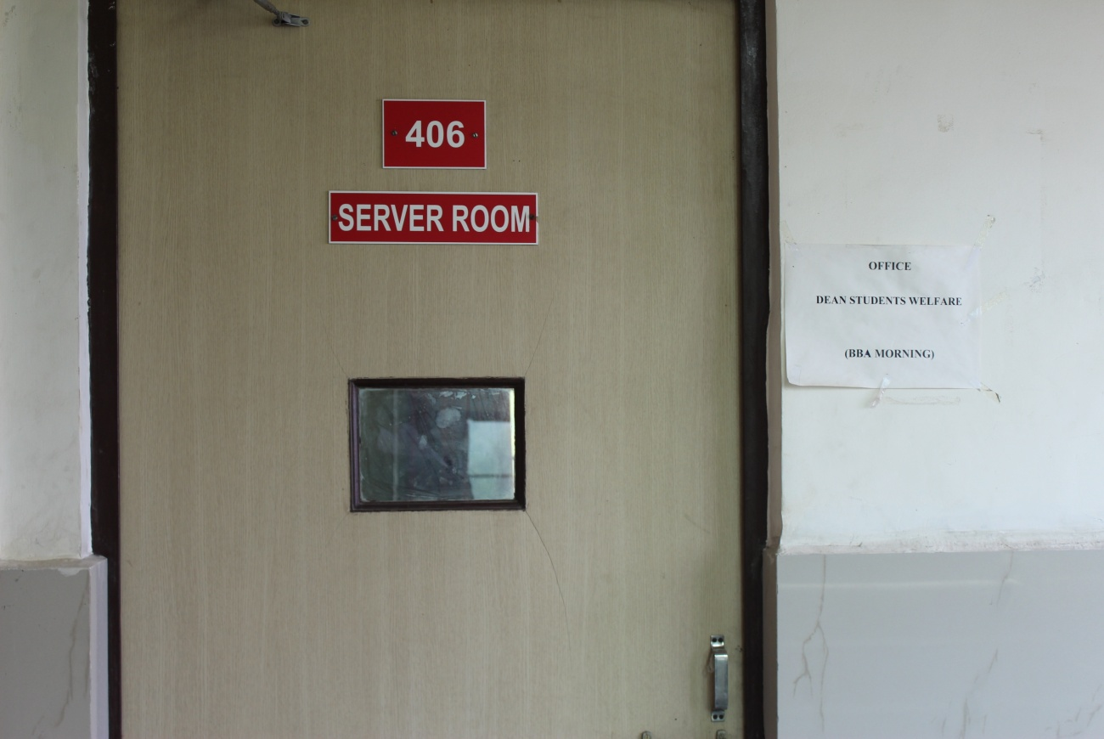
SERVER ROOM
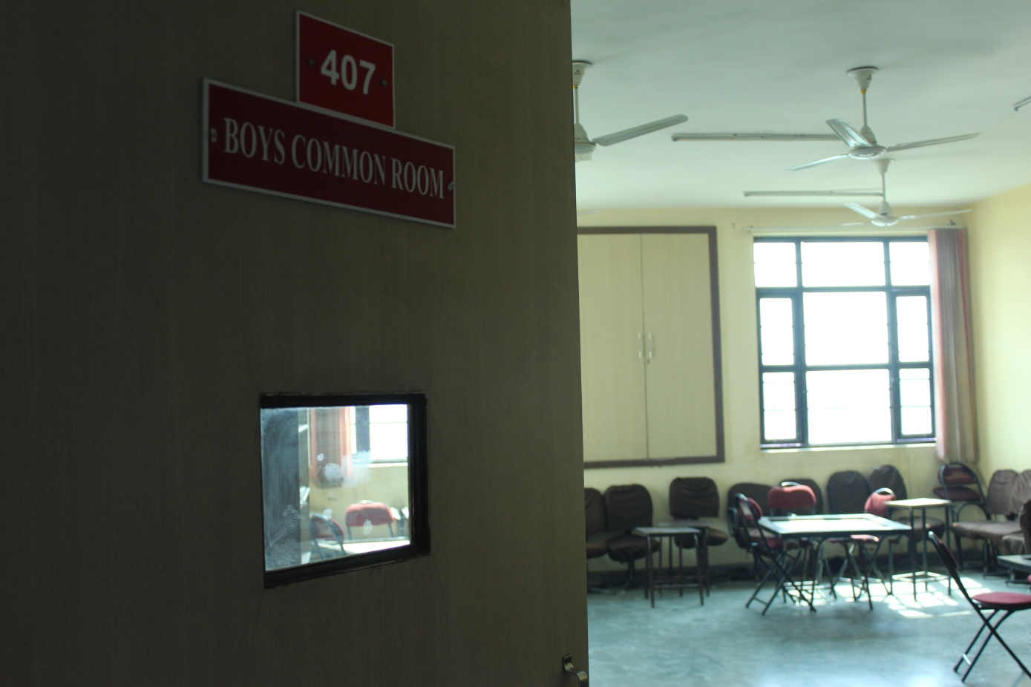
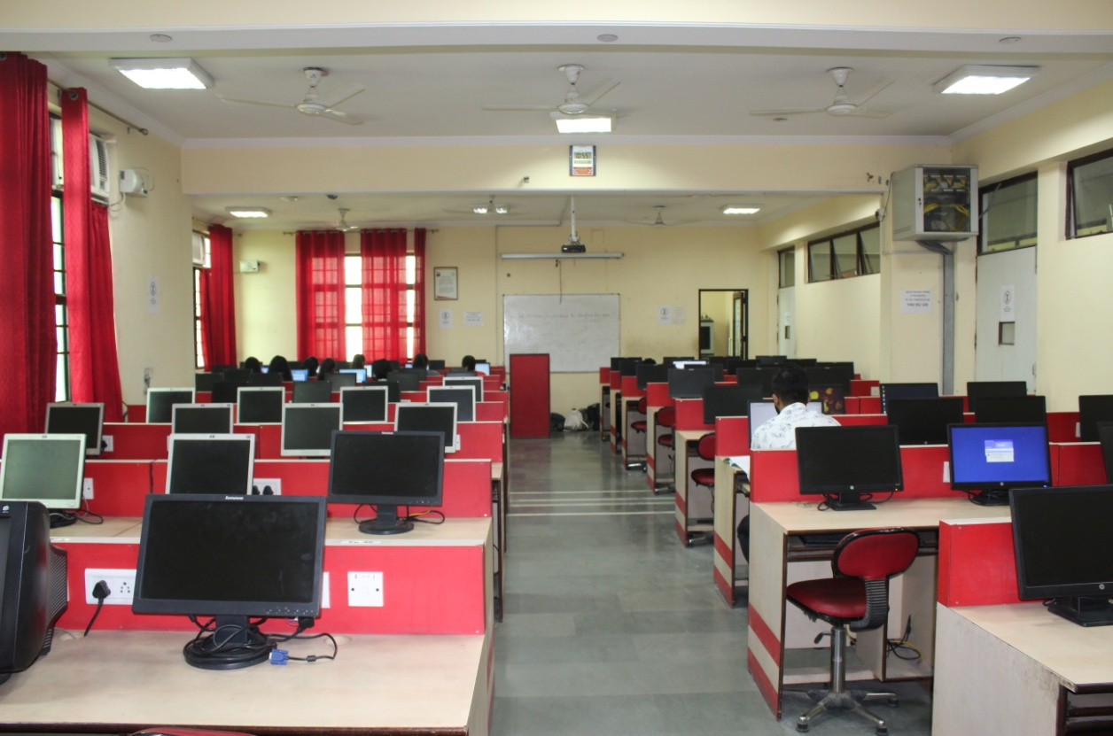
COMPUTER LAB
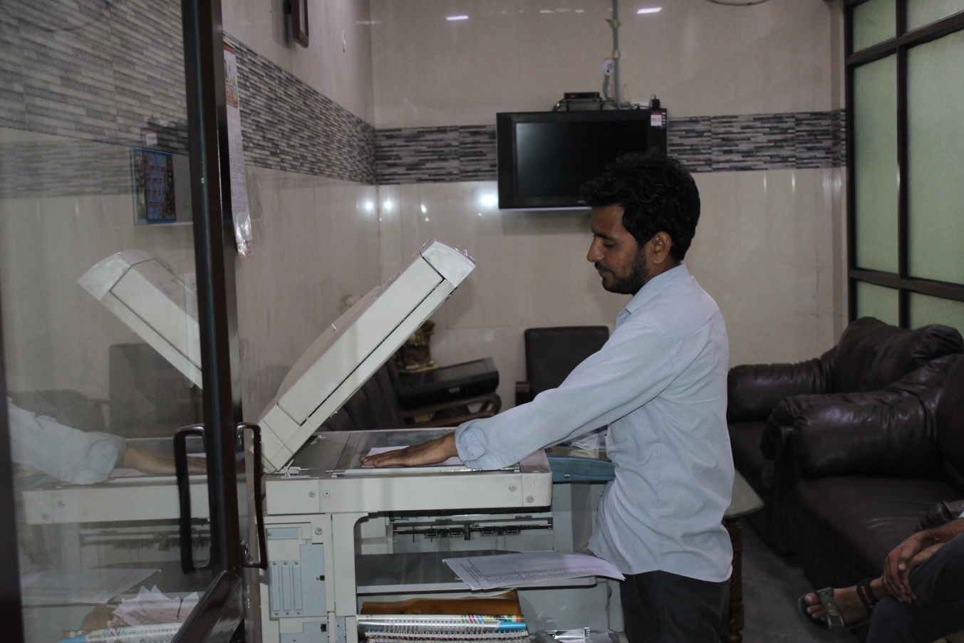
XEROX FACILITY
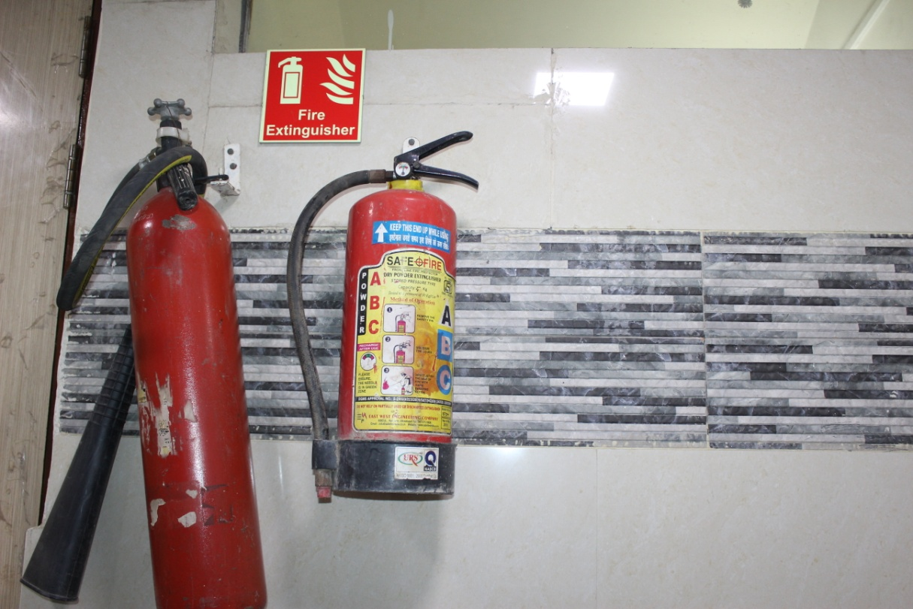
FIRE SAFETY DEVICE

HELP DESK
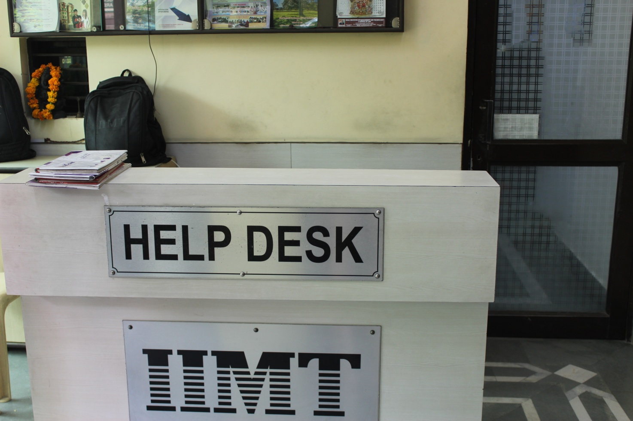

6.2.2
http://idealinstitute.edu.in/governing-body.php

6.2.3
BHAGWAR DOCUMENT

SCREEN SHOTS
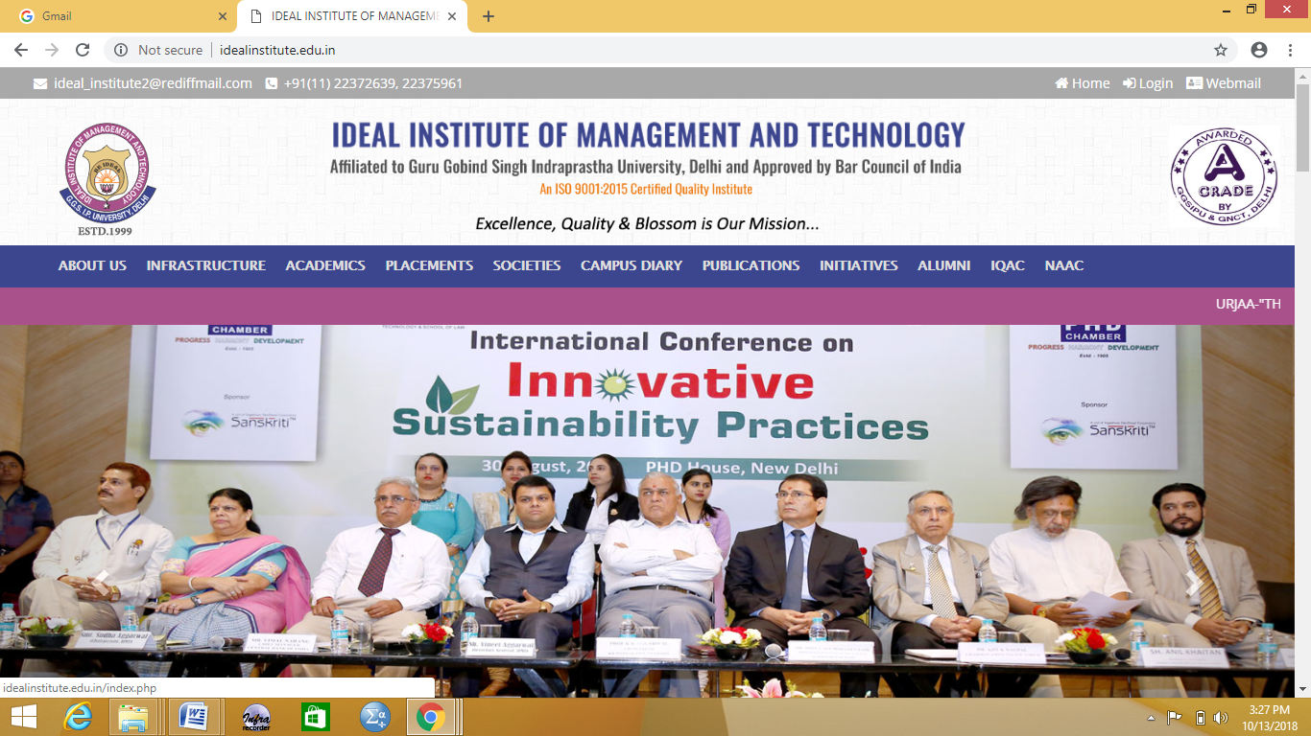
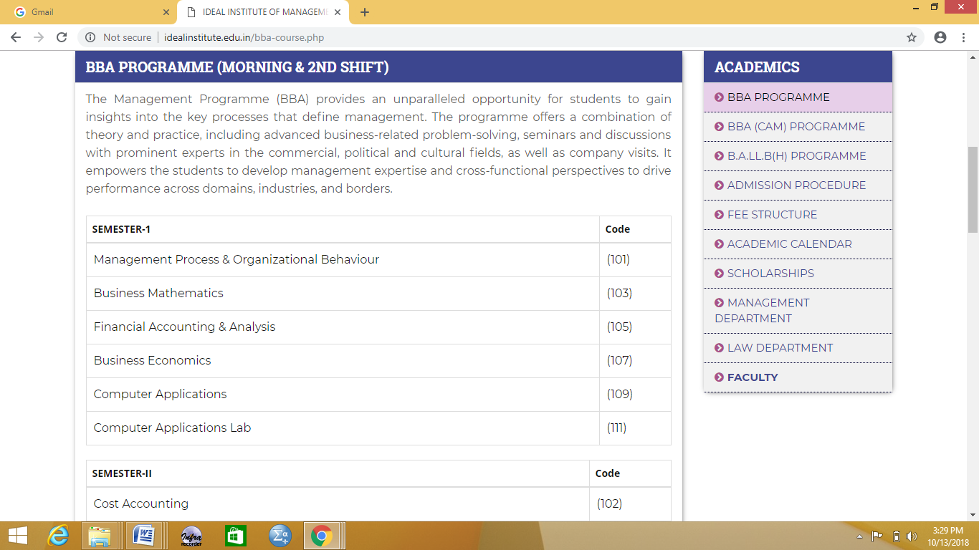

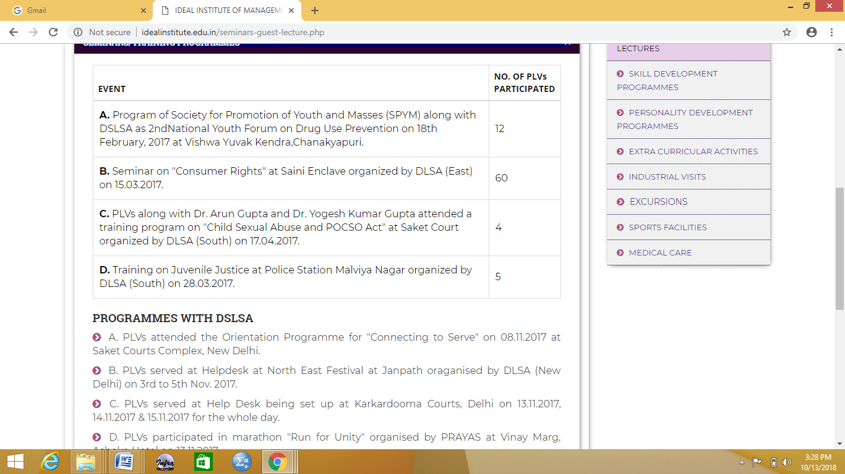

6.3.2

S. No. | Faculty Name | Amount Paid | Date of Payment | Seminar/ Conference/ Workshop/ FDP | Held at | Held on
1 | Dr. Vineeta Sharma  Dr. Shobhit Wadhwa  Seema Nath  Charu Saini  Anshika Rajvanshi  Mahesh Sharma  Shweta Nanda | 3500 | 15/01/2015 | FDP | Sant Hari Dass College | 15th - 20th Jan., 2015
2 | Sonal Goel  Renu Yadav  Parminder Kaur  Mahesh Sharma | 1200 | 12/02/2015 | Conference | Trinity Institute of Professional Studies | 21st Feb., 2015
3 | Anjali Munde | 1500 | 12/02/2015 | Conference | DAV College | 12th - 14th Feb., 2015
4 | Anil Sharma  Keshav Kumar Gupta | 3300 | 22/02/2015 | Workshop | Modern College of Professional Studies | 22nd - 28th Feb., 2015
5 | Seema Gupta | 6000 | 27/02/2015 | Conference | Bharati Vidyapeeth | 11th - 13th Mar., 2015
6 | Dr. Anil Parkash Sharma  Dr. Shobhit Wadhwa | 4000 | 04/03/2015 | Seminar | Ramgarhia College | 3rd - 4th Mar., 2015
7 | Seema Nath  Parminder Kaur | 700 | 11/03/2015 | Workshop | Gandhi Peace Foundation | 25th April, 2015
8 | Seema Nath  Neha Manchanda | 3000 | 13/03/2015 | Conference | Maharaja Argasen College | 13th - 14th March, 2015
9 | Renu Yadav | 500 | 14/03/2015 | Seminar | IITM | 14th Mar., 2015
10 | Sonal Goel  Renu Yadav  Jasmandeep Kaur | 4000 | 16/03/2015 | Conference | Rukmini Devi Institute of Advanced Studies
11 | Anjali Dhiman | 3500 | 19/03/2015 | Conference | IMS Engineering College | 19th Mar., 2015
12 | Anshika Rajvanshi  Jasmandeep Kaur | 2000 | 21/03/2015 | Conference | Maharaja Surajmal Institute | 21st Mar., 2015
13 | Dr. Anil Parkash Sharma  Shweta Nanda | 3000 | 23/03/2015 | Conference | USMS, GGS IP Univ. | 20th Mar., 2015
14 | Nikita Jain | 1500 | 25/03/2015 | Conferece | Rukmini Devi Institute of Advanced Studies
15 | J.P. Joshi | 2200 | 25/03/2015 | Conference | SRFLISindia - Org (Regd.) | 11th – 12th  April, 2015
16 | Sonal Goel  Deepa Jain | 1000 | 27/03/2015 | Seminar | Gitarattan International Business School | 27th Mar., 2015
17 | Sonal Goel  Seema Nath  Mahesh Sharma  Satpal Arora  Dr. Shobhit Wadhwa  Charu Saini | 3600 | 05/05/2015 | Workshop | Guru Ramdass College of Education | 4th - 6th May, 2015
18 | Sonal Goel  Jasmandeep Kaur  Renu Yadav  Shweta Nanda  Shilpa | 8500 | 11/05/2015 | Conference | Rukmini Devi Institute of Advanced Studies | 2nd - 6th June, 2015
19 | Renu Yadav  Jasmandeep Kaur  Gagneet Kaur Bhatia  Sumit Kumar Debnath | 6000 | 14/05/2015 | FDP | Institute of Management Studies | 4th July, 2015
20 | Tanu Narang | 1500 | 29/05/2015 | Conference | Rukmini Devi Institute of Advanced Studies | 2nd - 6th June, 2015
21 | Shweta Nanda  Seema Gupta | 500 | 04/06/2015 | Workshop | USMS, GGS IP Univ. | 18th - 22nd May, 2015
22 | Parminder Kaur  Nikita Jain | 4000 | 01/08/2015 | FDP | Guru Nanak Institute of Management | 1st - 2nd Aug., 2015
23 | Shailja Khosla | 2000 | 09/09/2015 | Conference | USMS, GGS IP Univ. | 14th Aug., 2015
24 | Seema Gupta | 500 | 09/10/2015 | Seminar | IMS Engineering College, Ghaziabad | 09/10/2015
25 | Seema Gupta | 1200 | 13/10/2015 | Conference | Babasaheb Bhimrao Ambedkar University, Lucknow | 31st Oct. - 2nd Nov., 2015
26 | Renu Yadav  Jasmandeep Kaur | 1000 | 16/10/2015 | Workshop | Jaypee Institute of Information Technology | 16th Oct., 2015
27 | Renu Yadav  Jasmandeep Kaur | 1500 | 28/10/2015 | Conference | Institute of Management | 28th Nov., 2015
28 | Renu Yadav | 1000 | 20/11/2015 | Workshop | Noida International University | 24th Nov., 2015
29 | Anjali Munde | 4560 | 01/12/2015 | 50th Golden Jubilee Annual Convention | CSI-2015 | 2nd - 5th Dec., 2015
30 | Jitender Yadav | 500 | 18/12/2015 | Workshop | Psychological Instruments and their Utility in Education & Sports | 18th - 20th Dec., 2015
31 | Dr. Shobhit Wadhwa  Charu Saini | 1000 | 23/12/2015 | FDP | Kasturi Ram College of Higher Education | 18th - 22nd Dec., 2015
32 | Anshika Rajvanshi | 500 | 27/02/2016 | Conference | The Business School, univ. of Jammu | 26th - 27th Feb 2016
33 | Dr. Shobhit Wadhwa  Charu Saini | 1600 | 04/03/2016 | Seminar | Guru Ram Dass College of Education | 4th - 5th March, 2016
34 | Sonal Goel | 400 | 30/03/2016 | Seminar | Satyawati College, University of Delhi | 30th March 2016
35 | Gagneet Kaur Bhatia  Nikita Jain | 4000 | 23/04/2016 | International Conference | Rukmini Devi Institute of Advanced Studies | 23rd April, 2016
36 | Sumit Kumar Debnath | 500 | 13/01/2017 | Seminar | GGS IP University | 13th Jan 2017
37 | Seema Gupta | 1000 | 16/03/2017 | Workshop | Babasaheb Bhimrao Ambedkar Univ., Lucknow | 20th - 24th March 2017
38 | Jitender Yadav | 400 | 24/03/2017 | Workshop | Devi Ahilya Vishwavidyalaya, Indore | 24th - 25th March 2017
39 | Satpal Arora | 500 | 25/03/2017 | Conference | Trinity Institute of Professional Studies, Dwarka | 25th March 2017
40 | Anshika Rajvanshi | 500 | 25/03/2017 | Conference | Trinity Institute of Professional Studies, Dwarka | 25th March 2017
41 | Mahesh Sharma | 500 | 25/03/2017 | Conference | Trinity Institute of Professional Studies, Dwarka | 25th March 2017
42 | Harsh Kalra | 500 | 25/03/2017 | Conference | Trinity Institute of Professional Studies, Dwarka | 25th March 2017
43 | Renu Yadav | 500 | 07/07/2017 | Management Development Programme | Jaipuria School of Business, Ghaziabad | 8th July 2017
44 | Jasmandeep Kaur | 500 | 07/07/2017 | Management Development Programme | Jaipuria School of Business, Ghaziabad | 8th July 2017
45 | Rakhi Gangal | 2500 | 14/07/2017 | Faculty Development Programme | Bharti Vidyapeeth Institute of Computer Applications & Management | 24th - 29th July 2017
46 | Seema Gupta | 2000 | 14/07/2017 | Faculty Development Programme | Bharti Vidyapeeth Institute of Computer Applications & Management | 24th - 29th July 2017
47 | Mahesh Sharma | 2000 | 16/12/2017 | International Conference | Sunrise University, Alwar | 16th - 17th Dec 2017
48 | Satpal Arora | 2000 | 16/12/2017 | International Conference | Sunrise University, Alwar | 16th - 17th Dec 2017
49 | Amarjit Kaur Sahni | 800 | 10/01/2018 | Seminar | Amity University | 18th - 19th Jan 2018
50 | Shailja Khosla | 500 | 24/01/2018 | Seminar | Gargi College, University of Delhi | 19th - 20th Jan 2018
51 | Seema Nath | 8000 | 29/01/2018 | International Conference | Bharati Vidyapeeth Institute of Computer Applications & Management | 15th March 2018
52 | Ruchi Kalia | 500 | 09/02/2018 | Conference | Delhi Technical Campus, Gr. Noida | 9th Feb 2018
53 | Shailja Khosla | 500 | 09/02/2018 | Conference | Delhi Technical Campus, Gr. Noida | 9th Feb 2018
54 | Gagneet Kaur Bhatia | 500 | 09/02/2018 | Conference | Delhi Technical Campus, Gr. Noida | 9th Feb 2018
55 | Nikita Jain | 500 | 09/02/2018 | Conference | Delhi Technical Campus, Gr. Noida | 9th Feb 2018
56 | Parminder Kaur | 500 | 09/02/2018 | Conference | Delhi Technical Campus, Gr. Noida | 9th Feb 2018
57 | Seema Nath | 500 | 09/02/2018 | Conference | Delhi Technical Campus, Gr. Noida | 9th Feb 2018
58 | Sonal Goel | 500 | 09/02/2018 | Conference | Delhi Technical Campus, Gr. Noida | 9th Feb 2018
59 | Satpal Arora | 500 | 09/02/2018 | Conference | Delhi Technical Campus, Gr. Noida | 9th Feb 2018
60 | Jasmandeep Kaur | 500 | 18/03/2018 | Seminar | Govt. Degree College, Nanauta, Saharanpur | 18th - 19th March 2018
61 | Renu Yadav | 500 | 18/03/2018 | Seminar | Govt. Degree College, Nanauta, Saharanpur | 18th - 19th March 2018
62 | Dr. Vineeta Sharma | 1000 | 23/03/2018 | Conference | Ramanujan College, Kalkaji, N. Delhi | 22nd - 23rd March 2018
63 | Sonal Goel | 500 | 23/03/2018 | Conference | Ramanujan College, Kalkaji, N. Delhi | 22nd - 23rd March 2018
64 | Deepa Jain | 5000 | 23/03/2018 | 4 days Research Scholars Conclave | ABV Indian Institute of Information Tech. | 5th - 8th April 2018
65 | Rakhi Gangal | 500 | 26/03/2018 | Seminar | Maharaja Agrasen Institute of Technology, Rohini | 26th March 2018
66 | Dr. Seema Gupta | 1000 | 13/04/2018 | International Conference | Rukmini Devi Institute of Advanced Studies, Rohini | 12th - 13th April 2018
67 | Sumit Kumar Debnath | 2000 | 17/04/2018 | International Conference | Rukmini Devi Institute of Advanced Studies, Rohini | 12th - 13th April 2018

6.3.3

YEAR | S.NO | Title of the professional development program organised for teaching staff | Title of the administrative training program organised for non-teaching staff | Dates (from-to) | No of participants (Teaching staff
2013-2014 | 1 | International Seminar on” psychological development of students in and outside the class room” |  | 22nd Jan 2014 | 54
2013-2014 | 2 | International Seminar on “Companies at 2013 an era of New opportunities and challenges” |  | 23rd Jan 2014 | 54
2013-2014 | 3 | National seminar on “ Recent trends & challenges in management practices and recent trend in computing & communication technologies | --- | 24th Jan 2014 | 54
2014-2015 | 4 | International Seminar on “ Climate change and Law: Its Impact on the Indian environmental Jurisprudence” | ---- | 20th Jan 2015 | 47
2014-2015 | 5 | International Seminar on “Globalization and its impact on management and IT” |  | 21st Jan 2015 | 47
2014-2015 | 6 | International Seminar on “ education in Transition : Moving towards a performance driven teaching and learning culture” |  | 22nd Jan 2015 | 47
2015-2016 | 7 | International Seminar on “ Emerging trends , challenges & innovative approaches in management and IT “ | ---- | 21st Jan 2016 | 54
2015-2016 | 8 | International Seminar on “ Reconceptulizing education towards effective learning for sustainable learning” |  | 22nd Jan 2016 | 54
2015-2016 | 9 | International Seminar on “ Relationship between the union and the state a constitutional dilemma” |  | 23rd Jan 2016 | 54
2015-2016 | 10 | 3-day faculty Development Programme on:  “Spiritual Development leading to Personality Development with the theme ‘U+ I = WE’  Creative & Play in the Organisation  Know Yourself” | ---- | 11-13 July,2016 | 54
2015-2016 | 11 | Workshop on “Empirical Research & Paper Development” | ---- | 14th & 15th July,2016 | 54
2015-2016 | 12 | Workshop on  “ Consumer awareness about banking schemes & operations” | ----- | 26th July,2016 | 54
2016-2017 | 13 | International conference on “ Innovative sustainability practices” | ----- | 30th Aug 2016 | 54
2016-2017 | 14 | Faculty Development Programme on  ” Are you a Target of Narcissistic Abuse? | ------ | 20TH August,2016 | 54
2016-2017 | 15 | Faculty Development Programme on “ Psychological Defence Mechanism” | ----- | 17th September,2016 | 54
2016-2017 | 16 | Faculty Development Programme on “ Games People Play” | ---- | 28th October,2016 | 54
2016-2017 | 17 | Faculty Development Programme on “ Why People lie- Psychology of Lying” | ---- | 25th November,2016 | 54
2016-2017 | 18 | Faculty Development Programme on “ How to develop A winning Attitude in life” | ---- | 22nd December,2016 | 54
2016-2017 | 19 | International Law Seminar on “Impact of Terrorism on International relation a legal insight” |  | 21st Jan 2017 | 54
2016-2017 | 20 | Faculty Development Programme on “ Does positivity enhance work performance?” | ---- | 31st January,2017 | 54
2016-2017 | 21 | PDP on “what I learnt from my life” | ----- | 31st Jan 2017 | 54
2016-2017 | 22 | Faculty Development Programme on “Corporate Chanakya" | ---- | 28th Feb 2017 | 54
2016-2017 | 23 | National Workshop cum Faculty Development Workshop on “Multi Disciplinary Approach in law and applicability of research in All management” | ----- | 17th -22nd July 2017 | 54
2017-2018 | 24 | Faculty Development Programme on “Enhancing teaching and research capabilities of management and legal educators in the era of digitalization” | ----- | 17-23rd July 2018 | 52
2017-18 | 25 | Conference on “ Socio legal impact of economic reforms in India : A Gobal perspective” | ---- | 20th Jan 2018 | 52

6.3.4
PROFESSIONAL DEVELOPMENT PROGRAMME ORGANIZED BY THE INSTITUTION
YEAR | S.NO | Title of the professional development program organised for teaching staff | Title of the administrative training program organised for non-teaching staff | Dates (from-to) | No of participants (Teaching staff
2015-  2016 | 2 | 3-day faculty Development Programme on:  “Spiritual Development leading to Personality Development with the theme ‘U+ I = WE’  Creative & Play in the Organisation  Know Yourself” | ---- | 11-13 July,2016 | 54
2015-2016 | 3 | Workshop on “Empirical Research & Paper Development” | ---- | 14th & 15th July,2016 | 54
2015-2016 | 4 | Workshop on  “ Consumer awareness about banking schemes & operations” | ----- | 26th July,2016 | 54
2016-2017 | 5 | Faculty Development Programme on  ” Are you a Target of Narcissistic Abuse? | ------ | 20TH August,2016 | 54
2016-2017 | 6 | Faculty Development Programme on “ Psychological Defence Mechanism” | ----- | 17th September,2016 | 54
2016-2017 | 7 | Faculty Development Programme on “ Games People Play” | ---- | 28th October,2016 | 54
2016-2017 | 8 | Faculty Development Programme on “ Why People lie- Psychology of Lying” | ---- | 25th November,2016 | 54
2016-2017 | 9 | Faculty Development Programme on “ How to develop A winning Attitude in life” | ---- | 22nd December,2016 | 54
2016-2017 | 10 | Faculty Development Programme on “ Does positivity enhance work performance?” | ---- | 31st January,2017 | 54
2016-2017 | 11 | Faculty Development Programme on “Corporate Chanakya" | ---- | 28th Feb 2017 | 54
2016-2017 | 12 | National Workshop cum Faculty Development Workshop on “Multi Disciplinary Approach in law and applicability of research in All management” | ----- | 17th -22nd July 2017 | 54
2017-2018 | 13 | Faculty Development Programme on “Enhancing teaching and research capabilities of management and legal educators in the era of digitalization” | ----- | 17-23rd July 2018 | 52

PROFESSIONAL DEVELOPMENT PROGRAM ATTENDED BY THE FACULTY OUTSIDE THE COLLEGE WITHOUT FINANCIAL SUPPORT

Year. | NAME OF THE TEACHER  WHO ATTENDED | TITLE OF THE PROFESSIONAL DEVELOPMENT PROGRAM | Date and Duration (from-to)

2013-2014

2013-2014 | shivani gupta | Two week Workshop on computer programming | 20th may 2014 – 21st june 2014
2013-2014 | shivani gupta | Workshop on data analysis for mgmt research | 12th – 13th april 2014
2013-2014 | Nikita jain | FDP on “ Multivariate analysis – a conceptual overview | 25th july 2014
2013-2014 | Parminder kaur, seema nath jain, neha manchanda , shivani gupta | Workshop on Digital learning” | 27th feb 2014
2013-2014 | Dr Anil Prakash Sharma and Dr Shobhit Wadhwa, Ms Charu Saini, Seema nath jain, aditya dhawan, Mahesh Sharma, Dr Vineeta Sharma, yogesh gupta, anshika rajvanshi, jatinder kaur | FDP on “ role of ethics and human values in professional lives” | 14th march 2014
2013-2014 | Amarjit kaur and shivani gupta | workshop on “ M³ mathematical modeling with mathematics” | 20th march 2014

2014-2015

2014-2015 | Mahesh Sharma  Anshika Rajvanshi, Jatinder Kaur, Aditya Dhawan, Dr Yogesh Kumar Gupta | Faculty development programme on  “Role of ethics &human values in professional lives”at sant hari das college of higher education | 14th march 2014
2014-2015 | Seema Nath Jain and Amarjit kaur | Faculty development programme on  “computational mathematical & statistical techniques | 31st oct-1st nov 2014
2014-2015 | Mayank Gupta | FDP ON “ Research Method and data analysis tools” | 15-16th nov 2014
2014-2015 | Parminder kaur, tanu, nikita , gagneet kaur | Workshop on “ organizational transformation through strategic mgmt the grand stratesist | 27th – 29th nov 2014
2014-2015 | Dr Anil Prakash Sharma and Dr Shobhit Wadhwa, Ms Charu Saini, Dr Vineeta Sharma | FDP on incorporating global perspectives in administration teaching and research | 8th –12th Dec 2014
2014-2015 | Mayank gupta and sumit debnath | FDP on Recent trends and challenges in marketing | 1st and 2nd Dec 2014
2014-2015 | Dr Anil Prakash Sharma and Dr Shobhit Wadhwa, Ms Charu Saini, Seema nath jain, shweta nanda, anshika rajvanshi, Mahesh Sharma, Dr Vineeta Sharma | Faculty development programme on “ Life long learning in 21st century needs and essentials at sant hari das college of higher education | 15- 20th Jan 2015
2014-2015 | Neha manchanda and shivani gupta | Workshop on applied optimization models and computation | 28th ---30th jan 2015
2014-2015 | Anil Sharma  Keshav kumar gupta | “Workshop on “ research methodology , statistics and use of spss” | 22nd – 28th Feb 2015
2014-2015 | Dr. Hemlata Sharma | Biological profile in Emerald Who’s who in Asia
2014-2015 | Charu saini | Workshop on ICT skills in teacher education | 23rd -25th march 2015
2014-2015 | Mr Jasdeep Singh | Joint Training Course in “ Civil, Criminal, Service, Labour and Arbitration and Meditation Laws” | 25th April 2015
2014-2015 | Ms Seema Nath , Ms Parminder kaur | Workshop on “ copyright, patron and its impact” | 25th April 2015
2014-2015 | Dr Anil Prakash Sharma and Dr Shobhit Wadhwa, Ms Charu Saini, Seema nath jain, sonal goel, Mahesh Sharma, satpal arora Dr Vineeta Sharma | Workshop on “ E Learning Tools for teacher educators | 4th and 6th may2015
2014-2015 | Seema gupta and shweta nanda | Workshop on Data Analytics | 18th May ---22nd May 2015
2014-2015 | Shweta nanda, Tanu Narang and Ms Shilpa | FDP on R. M & Data Analysis using SPSS | 2nd June 2015
2014-2015 | Sonal Goel, renu yadav and jasmandeep kaur | FDP on SPSS AND MATLAB | 2nd – 6th June 2015
2014-15 | Dr. Hemlata Sharma | Capacity Development Programme on “CORPORATE LAWS” | 8-13TH June 2015
2014-2015 | Gagneet kaur and sumit debnath,Renu yadav,jasmandeep kaur | Faculty Development Programme on “ advanced research tools – structural quation Modelling | 4th July 2015

2015-16
Workshops/Skill Development Program/ FDP
Year. | NAME OF THE TEACHER  WHO ATTENDED | TITLE OF THE PROFESSIONAL DEVELOPMENT PROGRAM | Date and Duration (from-to)
2015-2016 | Parminder kaur and nikita jain | Faculty Development Programme on Research Methodology using SPSS | 1st And 2nd Aug 2015
2015-16 | Dr. Hemlata Sharma | Faculty Development Programme | 9th April, 2016
2015-16 | Dr Anil Prakash Sharma and Dr Shobhit Wadhwa | Workshop on “ Module Editing and videorecording of lectures for ePG Pathshala | 3rd, 4th and 5th Feb 2016
2015-16 | Dr Anil Prakash Sharma and Dr Shobhit Wadhwa, Ms Charu Saini | Workshop on “ Module Editing and videorecording of lectures for ePG Pathshala Project of UGC | 23rd, 24th and 25th and 26th Feb 2016
2015-2016 | Dr Shobhit Wadhwa, Ms Charu Saini | Faculty Devvelopment programme on “ Research in Social Sciences” | 18th---22nd Dec2015
2015-2016 | Mr Jitender Yadav | National Workshop on “ “Psychological Instruments and Their Utility in Education and Sports” | 18th—20th Dec 2015
2015-2016 | Ms Renu Yadav | Workshop on “Research Methodology and tools used in research | 24th Nov 2015
2015-2016 | Ms Renu Yadav and jasmandeep | Workshop on “ Palagarism and Refrence management using Mendley | 16th oct 2015

2016-17
Workshops
Year. | NAME OF THE TEACHER  WHO ATTENDED | TITLE OF THE PROFESSIONAL DEVELOPMENT PROGRAM | Date and Duration (from-to)
2016-2017 | Dr. Payal Jain | International Course of one week on Business and Human Rights | 8th July, 2017
2016-2017 | Renu yadav and jasmandeep Kaur | Management development Programme on “ Transforming Corporate Culture using digital marketing” | 8th July 2017
2016-2017 | Dr. Arun Gupta | Faculty-in-charge of rapporteur team for Technical Session IX at World Conference on Environment -2017 | 25th–26th March 2017
2016-2017 | Mr. Jasdeep Singh | “Innovative teaching learning and research in Law” | 29th May-3rd June, 2017
2016-2017 | Ms Prerna Gulati  Ms Vijeta verma | Faculty development programme on “ Innovative Teaching learning methods and research in law | 29th May-2nd June, 2017

2017-18
Workshops
Year. | NAME OF THE TEACHER  WHO ATTENDED | TITLE OF THE PROFESSIONAL DEVELOPMENT PROGRAM | Date and Duration (from-to)
2017-18 | Dr. Hemlata Sharma | WORKSHOP on Water Bodies of Delhi and ITS convention on World Wetlands Day Celebration | 2nd February, 2018
2017-18 | Dr. Hemlata Sharma | Invited as “Distinguished Panelist” in National Law Seminar on Litigating Equality: Are Human Rights Effective? | 11th November, 2017
2017-18 | Dr. Arun Gupta | Invited as Resource Person in International Conference on “Recent Financial Reforms in India: An Unfinished Agenda” | 24th-25th November, 2017
2017-2018 | Dr vijeta verma | Workshop on “ unfolding goods and service tax” | 9th sep 2017

IQAC REPORT SUMMARY

IQAC Report
Internal Quality Assurance Cell (IQAC)
The Internal Quality assurance Cell (IQAC) has been established in the College as per the requirement laid down by the National assessment and accreditation Council (NAAC) as a quality sustenance measure.
The prime task of the IQAC is to develop a system for conscious, consistent and catalytic improvement in overall performance of the Institutions. The IQAC will make a significant and meaningful contribution in the post-accreditation phase of the Institution. During the post-accreditation period, the IQAC will channelize all efforts and measures of the Institution towards promoting its academic excellence.
The Internal Quality Assurance Cell (IQAC) of IIMT was formed on 9th October,2017 as follows:
- Chairman - Prof. (Dr.) Anil Parkash Sharma
- Director - Prof. (Dr.) T P S Rathore
- Coordinator - Mr. Mahesh Sharma
- Executive Members(faculty members):
- Ms. Seema Nath Jain
- Dr.Arun Gupta
- Ms. Prerna Gulati
- Ms. Shailja Khosla
- Mr. Satpal Arora
- Ms. Parminder Kaur
- Mr. Mayank Gupta
- Ms. Jasmandeep Kaur
- Member, Management - Ms. Neetu Aggarwal
- Administrative Officers -
  - Dr. I S Suri,
  - Mr. Atul Gupta,
  - Ms. ShilpaJain,
  - Mr. Amit Mittal,
  - Mr. Himanshu Bansal
- Members, Local Society - Mr. Rajesh Aggarwal, Secretary, SRWA
- Student Representative - Ms. Jasmine Singh
- Alumni Representative - Mr. Bharat Sharma
- Member, Employer - Mr. Puneet Aggarwal( Vice – President)
- Industrialist - Mr. Manoj Gupta
- Stakeholder - Mr. Vijay Gupta

The objectives of the IQAC are:
- To ensure continuous improvement in the entire operations of the Institution.
- To ensure stakeholders connected with higher Education, namely parents, teachers, staff, and society in general, of its own quality and probity.

Benefits
IQAC will facilitate / contribute:
- To promote measures for the functioning of the Institution towards quality enhancement through initialization of quality culture and Institutionalization of best practices.
- To ensure a heightened level of clarity and focus in institutional functioning towards quality enhancement and internalization of the quality culture of NAAC for Quality and Excellence in Higher Education.

- To act as a dynamic system for quality changes in the Institution.
- To build a better system for internal communication and centralized documentation.
Functions
1. Development and application of quality benchmarks/ parameters for the various academic and administrative activities of the Institution.
2. Arrangement for feedback responses from students, parents and other stakeholders on quality-related processes of the institution.
3. Dissemination of information on the various quality parameters of higher education.
4. Documentation of the various programmes / activities leading to quality improvement.
5. Organization of workshops, seminars on quality related themes and promotion of quality circles.

6.4.1
Internal Financial Audit Report
The Audit objections raised by the auditor while performing the audit are dealt with, in the following manner :-

1. On receiving the audit objections report from the auditor, the concerned accounts and administrative staff, gives this report a top priority and prepare the documents/reply to settle the objections (if possible) before it goes up to the level of top management.

2. To resolve the backlog of audit objections, and for speedy resolution of audit objections, initiatives are taken to convene bipartite/tripartite meetings where possible.

3. The decision of these meetings are complied with immediately and necessary rectifications are done to resolve the audit objections.

6.4.2

Year | Name of the non government funding agencies/ individuals | Funds/ Grants received in Rs | Initiative
2016 | YOGESHWAR DEVI DAYAL | 15000 | CONFERENCE
2017 | CENTRAL BANK OF INDIA | 5000 | ADVERTISEMENT

6.5.3

YEAR | NAME OF THE QUALITY INITIATIVE BY IQAC | DATE OF CONDUCTING ACTIVITY | DURATION (FROM - TO) | NUMBER OF PARTICIPANTS
2017-2018 | - Ph.D. colloquium[4] | - 30th Dec 2017  - 8th feb 2018  - 27th march2018  - 21st april 2018 | ONE DAY | 52
 | - Mentorship Programme | 30th Jan 2018 | ONE DAY | 52
 | - Inchargeship Analysis: | - 29th may 2018(BBA FIRST SHIFT)  - 30th may 2018(BBA Second Shift)  - 31ST may 2018(Law) | ONE DAY | 52
 | - Result Analysis: | 1st June 2018 | one day | 52
 | - Pyramid Analysis | 1st June 2018 | one day | 52

6.5.4

Year | AQARs prepared/ submitted. (Yes /No) | Academic Administrative Audit (AAA) and initiation of follow up action | Participation in NIRF. (Yes /No) | ISO Certification. (Yes /No) | NBA or any other certification received. (Yes /No)
 | YES | YES | N.A | YES | N.A

